**SOUND SENSOR**

**ABOUT THE SENSOR:**

-This sensor is generally a module and is used to detect the sound signal and coverts into electrical signal.

-Sound detection sensor works similarly to our Ears, having diaphragm which converts vibration into signals. However, what’s different as that a sound sensor consists of an in-built capacitive microphone, peak detector and an amplifier (LM386, LM393, etc.) that’s highly sensitive to sound.

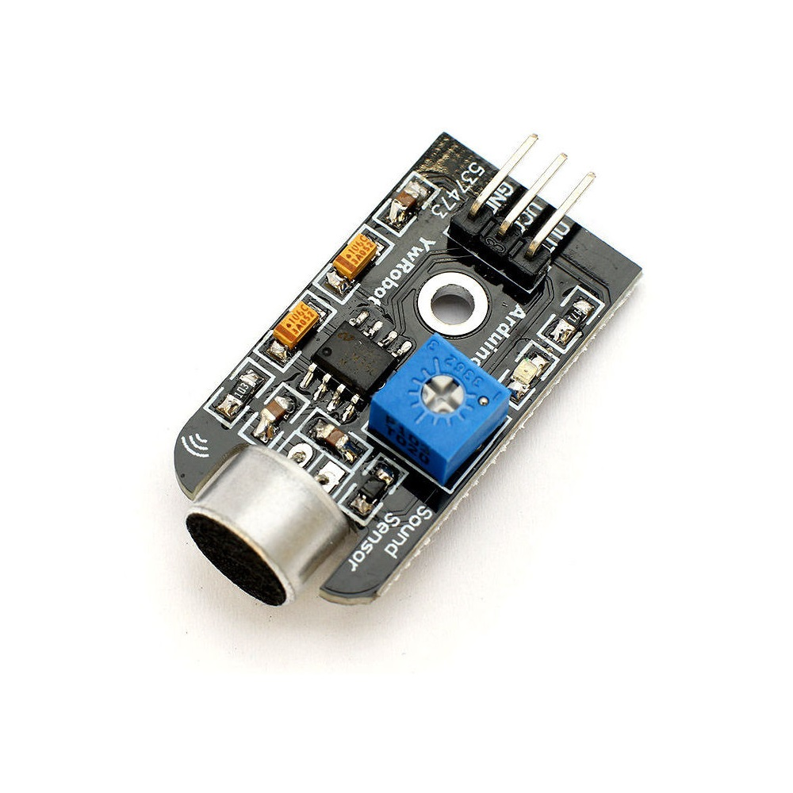

**WORKING:**

-Sound waves propagate through air molecules

-Such sound waves cause the diaphragm in the microphone to vibrate, resulting in capacitance change

-Capacitance change is then amplified and digitalized for processing of sound intensity and by this it operates.

**INTERFACING OF THE SENSOR WITH ARDUINO UNO**

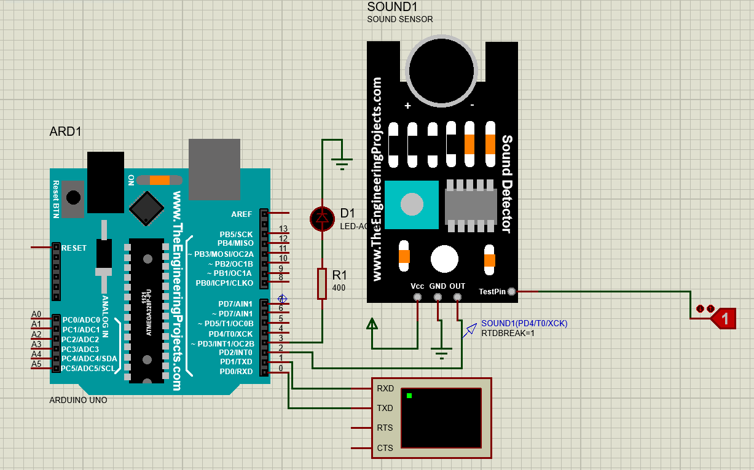

**PINOUTS:**

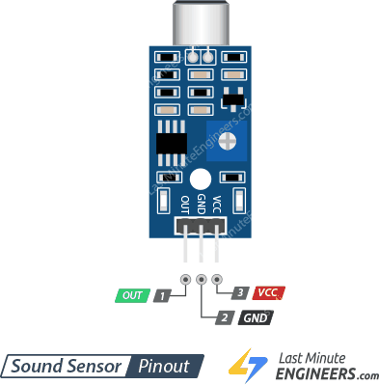

|  |  |  |
| --- | --- | --- |
| **PIN NUMBER** | **PIN NAME** | **PIN DESCRIPTION** |
| 1 | Out | The output of the digital signal(1/0) is taken from this pin. |
| 2 | Gnd | This pin is connected to the ground. |
| 3 | Vcc | The supply voltage from 3.3v to 5v is given to power the sensor. |

**APPLICATIONS:**

* Can be used for home automation projects like switching of bulbs or other electrical appliances with a clap or any other sound.
* Can be used for making burglary alarm for security.
* Can be used to measure the noise pollution in a particular place or area.

**CODE:**

void setup() {

// put your setup code here, to run once:

pinMode(2,INPUT);

Serial.begin(9600);

pinMode(3,OUTPUT);

}

void loop() {

// put your main code here, to run repeatedly:

int s=0;

s=digitalRead(2);

if(s!=0){

pinMode(3,HIGH);

Serial.println(s);

delay(1000);

}

}